PROFORMA INVOICE

Quotation no: B&F A PI-302
Date 08/11/2024

To,

B&F Realty-Villa 3
Goa

Dear Sir,
Kindly find the quotation as per your requirement.

ENDO

Sr No | Specification Description | Symbol | Manufacturer | Total Quantity | Remarks/ L@W Comments | BEST PRICE | Total
1 | LED Strip Light with flat Channel & Clear Cover. |  | ENDO LIGHTING
 | Housing: Extruded aluminium Channel & clear Cover. | COV1 | TSUKI-R-1714-10W/Mtr | 57.50 | SUGGEST IN 10W/Mt.  The actual Lengths required to be confirmed as per site., OLD QTY 55 MTR | 1172 | 67390
 | Dimension: 17 X 14mm |  | 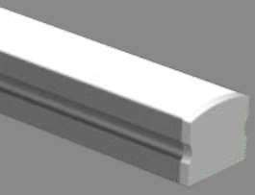 | Mtrs. |  | 1172 | 67390
 | Accessory: Channel & Clear Cover. |  |  |  |  | 1172 | 67390
 | Lamp: 15W/Mt, 3000K, CRI=90+ |  |  |  |  | 1172 | 67390
 | Lumen Output :1500lm/Mt |  |  |  |  | 1172 | 67390
 | Control Gear: Remote LED Driver. Dali Dimmable. |  |  |  |  | 1172 | 67390
 | Power Consumption: 10W/Mt |  |  |  |  | 1172 | 67390
 | IP20 |  |  |  |  | 1172 | 67390
 |  |  | 80W, 24V Dali Driver | 12.00 |  | 4992 | 59904
2 | LED Strip Light along circular cove. |  | ENDO LIGHTING |  |  | 4425 | 61950
 | Housing: Silicone | COV1c | TSUKI-NF-DB-16X16-NS-130- 14W-IP67 | 14.00 | OK.  The actual Length required in Circular cove, to be confirmed as per Site. | 4425 | 61950
 | Dimension: 16 X 16mm |  |  | Mtrs. |  | 4425 | 61950
 | Accessory: Fixing Clips |  |  |  |  | 4425 | 61950
 | Lamp: 14W/Mt LED, 120° 3000K, CRI=85+ |  |  |  |  | 4425 | 61950
 | Lumen Output : 710lm/Mt |  |  |  |  | 4425 | 61950
 | Control Gear: Remote LED Driver. Dali Dimmable. |  |  |  |  | 4425 | 61950
 | Power Consumption: 14W/Mt |  |  |  |  | 4425 | 61950
 | IP67 |  |  |  |  | 4425 | 61950
 |  |  | 80W, 24V Dali Driver | 3.00 |  | 4992 | 14976
 |  |  |  | Nos |  | 4992 | 14976
3 | LED Strip light with 45° Channel & Diffuse Cover. |  | ENDO LIGHTING |  |  | 1319 | 137836
 | Housing: Extruded aluminium 45° Channel & Diffuse Cover | COV2 | TSUKI-R-1818-10W/Mtr | 104.50 | OK.  Mounted in wardrobes & Curtain pelmets.  Actual lengths to be confirmed as per site. OLD QTY 88 MTR | 1319 | 137836
 | Dimension: 18 X18mm |  | 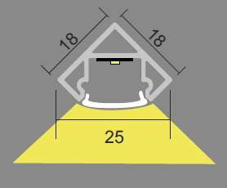 | Mtrs. |  | 1319 | 137836
 | Accessory: 45° Channel with Diffuse Cover |  |  |  |  | 1319 | 137836
 | Lamp: 10W/Mt LED, 3000K, CRI=90+ |  |  |  |  | 1319 | 137836
 | Lumen Output : 1000lm/Mt |  |  |  |  | 1319 | 137836
 | Control Gear: Remote LED Driver. Dali Dimmable. |  |  |  |  | 1319 | 137836
 | Power Consumption: 10W/Mt |  |  |  |  | 1319 | 137836
 | IP20 |  |  |  |  | 1319 | 137836
 |  |  | 80W, 24V Dali Driver | 21.00 |  | 4992 | 104832
4 | LED Strip Light with Flat Channel & Dotless Diffuse Cover |  | ENDO LIGHTING |  |  | 1172 | 79110
 | Housing: Extruded aluminium Channel & Diffuse Cover | COV3 | TSUKI-R-1714-10W/Mtr | 67.50 | OK.  For task Lighting in Kitchen.  Actual lengths to be confirmed as per Site., OLD QTY 62 MTR | 1172 | 79110
 | Dimension: 17 X 14mm |  |  | Mtrs. |  | 1172 | 79110
 | Accessory: Channel with Diffuse Cover |  |  |  |  | 1172 | 79110
 | Lamp: 10W/Mt LED, 3000K, CRI=90+ |  |  |  |  | 1172 | 79110
 | Lumen Output :100lm/Mt |  |  |  |  | 1172 | 79110
 | Control Gear: Remote LED Driver. Dali Dimmable. |  |  |  |  | 1172 | 79110
 | Power Consumption: 10W/Mt |  |  |  |  | 1172 | 79110
 | IP20 |  |  |  |  | 1172 | 79110
 |  |  | 80W, 24V Dali Driver | 14.00 |  | 4992 | 69888
5 | LED Strip Light with Channel & Dotless Diffuse Cover |  | ENDO LIGHTING |  |  | 1251 | 160754
 | Housing: Extruded aluminium Channel & Cover | COV4 | TSUKI-S-1714-5W/Mtr (IP65) | 128.50 | IP65 Required  Actual Length to be confirmed as per site., OLD QTY 125 MTR & IP20 | 1251 | 160754
 | Dimension: 17mm X 14mm |  |  | Mtrs. |  | 1251 | 160754
 | Accessory: Channel with Diffuse Cover |  |  |  |  | 1251 | 160754
 | Lamp: 5W/Mt LED, 3000K, CRI=90+ |  |  |  |  | 1251 | 160754
 | Lumen Output : 500lm/Mt |  |  |  |  | 1251 | 160754
 | Control Gear: Remote LED Driver. Dali Dimmable. |  |  |  |  | 1251 | 160754
 | Power Consumption: 5W |  |  |  |  | 1251 | 160754
 | IP65 |  |  |  |  | 1251 | 160754
 |  |  | 80W, 24V Dali Driver | 14.00 |  | 4992 | 69888
6 | Flex Light with Top View |  | ENDO LIGHTING |  |  | 4425 | 40710
 | Housing: Silicone | FLX1 | TSUKI-NF-DB-16X16-NS-130- 9W-IP67 | 9.20 | 14W/Mt is too high, (5W/Mt to 7W/Mt LED required)  Actual Length to be confirmed as per site., OLD QTY 3.15 MTR | 4425 | 40710
 | Dimension: 16 X 16mm |  | TSUKI-NF-DB-16X16-NS-130- 9W-IP67 | Mtrs. |  | 4425 | 40710
 | Accessory: Fixing Clips |  |  |  |  | 4425 | 40710
 | Lamp: 9W/Mt LED, 120° 3000K, CRI=85+ |  |  |  |  | 4425 | 40710
 | Lumen Output : 710lm/Mt |  |  |  |  | 4425 | 40710
 | Control Gear: Remote LED Driver. Dali Dimmable. |  |  |  |  | 4425 | 40710
 | Power Consumption: 9W/Mt |  |  |  |  | 4425 | 40710
 | IP67 |  |  |  |  | 4425 | 40710
 |  |  | 80W, 24V Dali Driver | 2.00 |  | 4992 | 9984
 |  |  |  |  | OLD QTY 32 NOS | 9045 | 298485
7 | Ceiling Recessed LED Down Light (IP Rated) |  | ENDO LIGHTING |  | OLD QTY 32 NOS | 9045 | 298485
 | Housing: Die cast Aluminium | IPR1 | GERD8901W-T | 33.00 | OLD QTY 32 NOS | 9045 | 298485
 | Dimension:Trim∅=60mm, Ht=95mm | White Trim | 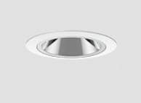 | Nos | OLD QTY 32 NOS | 9045 | 298485
 | Lamp: 10.2W LED, 23° Fixed,3000K, CRI=90+(R9≥40+) | White Trim |  |  | OLD QTY 32 NOS | 9045 | 298485
 | Lumen Output : 446lm |  |  |  | OLD QTY 32 NOS | 9045 | 298485
 | Control Gear: Remote LED Driver. Dali Dimmable. |  |  |  | OLD QTY 32 NOS | 9045 | 298485
 | Power Consumption: 10.2W |  |  |  | OLD QTY 32 NOS | 9045 | 298485
 | IP44 |  |  |  | OLD QTY 32 NOS | 9045 | 298485
8 | In-ground LED Up lighter. |  |  |  |  | 9317 | 139755
 |  | IUL1 | ELUIR1-70-0630-KN | 15.00 | Share the data sheet of this. | 9317 | 139755
 | ELUIR1-70-0630-KN  (Tsuki ingorund 5.8W, 9Deg, 3000K, 80 CRI, 70mm Dia, Non Dimmable ) |  |  | Nos | Share the data sheet of this. | 9317 | 139755
  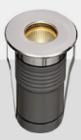
9 | Profile System , Recessed Magnetic Track. |  |  |  |  | 5842 | 70104
 | XR-CMT410 (48V DC Recess track with all accesoried) | PSY1 | Track | 12.00 | A recessed track with  trim preferred.  Share the data sheet of this.  Drawing to be shared with Vendor to finalize unit modules & connectors. | 5842 | 70104
 | XR-CMT410 (48V DC Recess track with all accesoried) |  |  | Nos |  | 5842 | 70104
  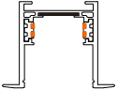
9a | Recessed Linear LED light in Profile System. |  | ENDO LIGHTING |  |  | 12491 | 112419
 | Housing: Aluminum + PC | M1 | FL-24G | 9.00 | Quantity will change since length is lesser. Refer the shared render given by I.D.  Share the IES file to evaluate. | 12491 | 112419
 | Dimension: L=485mm W=25mm, D=46mm |  | FL-24G | Nos |  | 12491 | 112419
 | Accessory: Recessing Track - Profile |  | 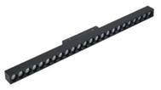 |  |  | 12491 | 112419
 | Lamp: 24W/485mm LED, 3000K, CRI=90+(R9≥40+) |  |  |  |  | 12491 | 112419
 | Lumen Output : 1000lm/300mm |  |  |  |  | 12491 | 112419
 | Control Gear: Remote LED Driver. Dali Dimmable. |  |  |  |  | 12491 | 112419
 | Power Consumption:24W/485mm |  |  |  |  | 12491 | 112419
 | IP20 |  |  |  |  | 12491 | 112419
9b | Recessed LED Twin Spot light in Profile System. |  | ENDO LIGHTING |  |  | 14514 | 174168
 | Housing: Aluminum | M2 | GERS7013BA-T(Mini 40 spot) | 12.00 | Quantity will change. Refer the shared render given by I.D.  Share the IES file to evaluate. | 14514 | 174168
 | Dimension: TrimØ=45mm, L=94mm & Ht=52mm |  | 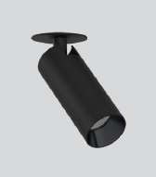 | Nos |  | 14514 | 174168
 | Accessory: Recessing Track - Profile |  |  |  |  | 14514 | 174168
 | Lamp: 10.2W LED 33°, 3000K, CRI=83+(R9≥40+) |  |  |  |  | 14514 | 174168
 | Lumen Output : 767lm |  |  |  |  | 14514 | 174168
 | Control Gear: Remote LED Driver. Dali Dimmable. |  |  |  |  | 14514 | 174168
 | Power Consumption: 10.2W |  |  |  |  | 14514 | 174168
 | IP20 |  |  |  |  | 14514 | 174168
10 | Ceiling Recessed LED Pin Spot Down Light. |  | GERD9898W-T |  |  | 5686 | 28430
 | Housing: Die cast aluminium | PNS1 |  | 5.00 | The alternate is missing in received BOQ, NEW ITEM | 5686 | 28430
  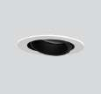
 | Dimension: Trim∅=37mm, CutOut∅=35mm Ht=42mm. |  |  | Nos | The alternate is missing in received BOQ, NEW ITEM | 5686 | 28430
 | Lamp: 3.1W LED 29°, Focusable, 3000K, CRI=93+(R9≥40+) |  |  |  | The alternate is missing in received BOQ, NEW ITEM | 5686 | 28430
 | Lumen Output: 178lm |  |  |  | The alternate is missing in received BOQ, NEW ITEM | 5686 | 28430
 | Control Gear: Remote LED Driver. Dali Dimmable. |  |  |  | The alternate is missing in received BOQ, NEW ITEM | 5686 | 28430
 | Power Cosumption: 3.1W |  |  |  | The alternate is missing in received BOQ, NEW ITEM | 5686 | 28430
 | IP20 |  |  |  | The alternate is missing in received BOQ, NEW ITEM | 5686 | 28430
11 | Ceiling Recessed LED Pin Spot Down Light. |  |  |  |  | 10552 | 84416
 | Housing: Die cast aluminium | PNS2 |  | 8.00 | The alternate is missing in received BOQ, NEW ITEM | 10552 | 84416
  GERD9869W-T
 | Dimension: Trim∅=60mm,Cut Out∅=50mm Ht=101mm. |  | 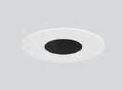 | Nos | The alternate is missing in received BOQ, NEW ITEM | 10552 | 84416
 | Lamp: 10.3W LED 21°, Focusable, 3000K, CRI=93+(R9≥40+) |  |  |  | The alternate is missing in received BOQ, NEW ITEM | 10552 | 84416
 | Lumen Output: 446lm |  |  |  | The alternate is missing in received BOQ, NEW ITEM | 10552 | 84416
 | Control Gear: Remote LED Driver. Dali Dimmable. |  |  |  | The alternate is missing in received BOQ, NEW ITEM | 10552 | 84416
 | Power Cosumption: 10.3W |  |  |  | The alternate is missing in received BOQ, NEW ITEM | 10552 | 84416
 | IP20 |  |  |  | The alternate is missing in received BOQ, NEW ITEM | 10552 | 84416
12 | Ceiling Recessed LED Down Light. |  | ENDO LIGHTING |  |  | 9621 | 355977
 | Housing: Aluminium | RDN1 | GSTDA1800W-AMH30 | 37.00 | Kindly Suggest ACCORD (2000 TYPE -  19.6W Middle Beam Angle), OLD QTY 32 NOS | 9621 | 355977
 | Dimension:∅=65mm, H=129mm. |  | 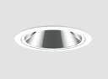 | Nos |  | 9621 | 355977
 | Lamp: 19.8W LED 23°, Focusable, 3000K, CRI=93+(R9≥40+) |  |  |  |  | 9621 | 355977
 | Lumen Output: 1243lm |  |  |  |  | 9621 | 355977
 | Control Gear: Remote LED Driver. Dali Dimmable. |  |  |  |  | 9621 | 355977
 | Power Cosumption: 19.8W |  |  |  |  | 9621 | 355977
 | IP20 |  |  |  |  | 9621 | 355977
13 | Ceiling Reccesed LED Down Light. |  | ENDO LIGHTING |  |  | 9621 | 221283
 | Housing: Aluminium | RDN2 | GSTDA1800W-AWH30 | 23.00 | Kindly Suggest ACCORD (2000 TYPE -  19.6W Wide Beam Angle), OLD QTY 32 NOS | 9621 | 221283
 | Dimension:L=∅=65mm, H=129m. |  |  | Nos |  | 9621 | 221283
 | Lamp: 19.8W LED 33°, Focusable, 3000K, CRI=93+(R9≥40+) |  |  |  |  | 9621 | 221283
 | Lumen Output: 1368lm | 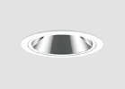 |  |  |  | 9621 | 221283
 | Control Gear: Remote LED Driver. Dali Dimmable. |  |  |  |  | 9621 | 221283
 | Power Cosumption: 19.8W |  |  |  |  | 9621 | 221283
 | IP20 |  |  |  |  | 9621 | 221283
14 | Ceiling Reccesed LED Twin Down Light.  (Black Trim Required) |  |  |  |  | 17792 | 569344
 | Housing: Die cast aluminium ( Cust to Black Trim ) | RDN3 | GERD8849W-T | 32.00 | Black Trim Finish (I.D to confirm)  This is OK. | 17792 | 569344
 | Dimension: o 122 X65mm & H=115mm |  |  | Nos | Black Trim Finish (I.D to confirm)  This is OK. | 17792 | 569344
  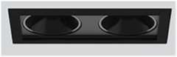
 | Lamp:14.2W LED, 26°, Focusable, 3000K, CRI=93+(R9≥40+) |  |  |  | Black Trim Finish (I.D to confirm)  This is OK. | 17792 | 569344
 | Lumen Output : 1254lm |  |  |  | Black Trim Finish (I.D to confirm)  This is OK. | 17792 | 569344
 | Control Gear: Remote LED Driver. Dali Dimmable. |  |  |  | Black Trim Finish (I.D to confirm)  This is OK. | 17792 | 569344
 | Power Consumption: 14.2W/Unit |  |  |  | Black Trim Finish (I.D to confirm)  This is OK. | 17792 | 569344
 | IP20 |  |  |  | Black Trim Finish (I.D to confirm)  This is OK. | 17792 | 569344
15 | Ceiling Recessed LED Down Light |  |  |  |  | 11253 | 168795
 | Housing: Die cast aluminium ( Cust to Black Trim ) | RDN4b | GERD8127WA-T (CUSTOMISED TO BLACK TRIM) | 15.00 | Black Trim Finish (In Bedroom 04 sloping ceiling)  This is OK. | 11253 | 168795
 | Dimension: ∅=108mm, Depth=100mm. |  |  | Nos |  | 11253 | 168795
  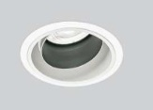
 | Lamp: 19.8W LED,19°, Focusable ,3000K CRI=96+(R9≥40+) |  |  |  |  | 11253 | 168795
 | Lumen Output : 1377lm |  |  |  |  | 11253 | 168795
 | Control Gear: Remote LED Driver. Dali Dimmable. |  |  |  |  | 11253 | 168795
 | Power Consumption: 19.8W |  |  |  |  | 11253 | 168795
 | IP20 |  |  |  |  | 11253 | 168795
16 | Ceiling Recessed LED Down Light |  |  |  |  | 11253 | 135036
 | Ceiling Recessed LED Down Light | RDN4w | GERD8127WA-T | 12.00 | . NEW ITEM | 11253 | 135036
 | Housing: Die cast aluminium |  |  | Nos | . NEW ITEM | 11253 | 135036
 | Dimension: ∅=108mm, Depth=100mm. |  |  |  | . NEW ITEM | 11253 | 135036
 | Lamp: 19.8W LED,19°, Focusable ,3000K CRI=96+(R9≥40+) |  |  |  | . NEW ITEM | 11253 | 135036
 | Lumen Output : 1377lm |  |  |  | . NEW ITEM | 11253 | 135036
 | Control Gear: Remote LED Driver. Dali Dimmable. |  |  |  | . NEW ITEM | 11253 | 135036
 | Power Consumption: 19.8W |  |  |  | . NEW ITEM | 11253 | 135036
 | IP20 |  |  |  |  | 11253 | 135036
17 | Ceiling Recessed LED Down Light |  |  |  |  | 13401 | 67005
 | Housing: Die cast aluminium | RDN5 | GERD8202WB-T | 5.00 | This is OK. | 13401 | 67005
 | Dimension: ∅=108mm, Depth=133mm. |  |  | Nos | This is OK. | 13401 | 67005
  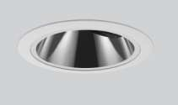
 | Lamp: 28.5W LED, 32°, Fixed Optics, 3000K CRI=83+(R9≥40+) |  |  |  | This is OK. | 13401 | 67005
 | Lumen Output : 1597lm |  |  |  | This is OK. | 13401 | 67005
 | Control Gear: Remote LED Driver. Dali Dimmable. |  |  |  | This is OK. | 13401 | 67005
 | Power Consumption: 28.5W |  |  |  | This is OK. | 13401 | 67005
 | IP20 |  |  |  | This is OK. | 13401 | 67005
18 | Surface Mounted LED Down Light. |  |  |  |  | 3908 | 54712
 | Housing: Die cast aluminium | SDN1 |  | 14.00 | OLD QTY 10 NOS. WE HAVE PROPOSED ALTERNATE ECONOMICAL OPTION IN Abby BRAND. | 3908 | 54712
  Abby Surface Down light 14W, 3000K
 | Dimension: ∅=152mm & H=38mm. |  |  | Nos |  | 3908 | 54712
 | Lamp:15W LED, Flood Beam, Fixed, 3000K, CRI=85+(R9≥40+) | 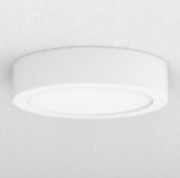 |  |  |  | 3908 | 54712
 | Lumen Output : 1209lm |  |  |  |  | 3908 | 54712
 | Control Gear: LED Driver. Dali Dimmable. |  |  |  |  | 3908 | 54712
 | Power Consumption: 15W |  |  |  |  | 3908 | 54712
 | IP44 Required |  |  |  |  | 3908 | 54712
19 | Ceiling Recessed LED Light, Fixed. | SDN2 | GERD8604W-T | 12.00 |  | 10345 | 124140
 | Housing: Die cast aluminium |  |  | Nos |  | 10345 | 124140
  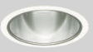
 | Dimension: ∅=108mm, Cutout∅=100 & Height=110mm. |  |  |  |  | 10345 | 124140
 | Lamp:19.3W LED, 31° Fixed, 3000K, CRI=85(R9≥40+) |  |  |  |  | 10345 | 124140
 | Lumen Output : 2014lm |  |  |  |  | 10345 | 124140
 | Control Gear: Remote LED Driver. Dali Dimmable. |  |  |  |  | 10345 | 124140
 | Power Consumption: 19.3W |  |  |  |  | 10345 | 124140
 | IP44 Required |  |  |  |  | 10345 | 124140
20 | Spike Mounted LED Projector Light. |  |  | 11.00 | OLD QTY 6 | 10819 | 119009
  GERS6922H-T
 | Housing: Alluminium | SPK1 | 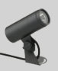 | Nos | OLD QTY 6 | 10819 | 119009
 | Dimension: ∅=61mm, Ht=141mm |  |  |  | OLD QTY 6 | 10819 | 119009
 | Lamp:10W LED,23º, 3000K CRI=80+ |  |  |  | OLD QTY 6 | 10819 | 119009
 | Lumen Output : 758lm |  |  |  | OLD QTY 6 | 10819 | 119009
 | Control Gear: Remote LED Driver. Non-Dimmable. |  |  |  | OLD QTY 6 | 10819 | 119009
 | Power Consumption: 10.1W |  |  |  | OLD QTY 6 | 10819 | 119009
 | IP65 |  |  |  | OLD QTY 6 | 7530 | 82830
21 | Spike Mounted LED Projector Light. |  |  | 11.00 | OLD QTY 6 | 7530 | 82830
  GERS7306H-T +GRB898N
 | Housing: Alluminium | SPK2 | 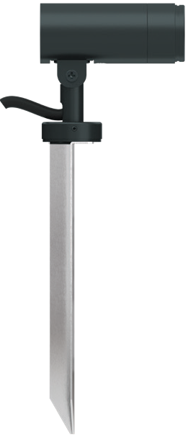  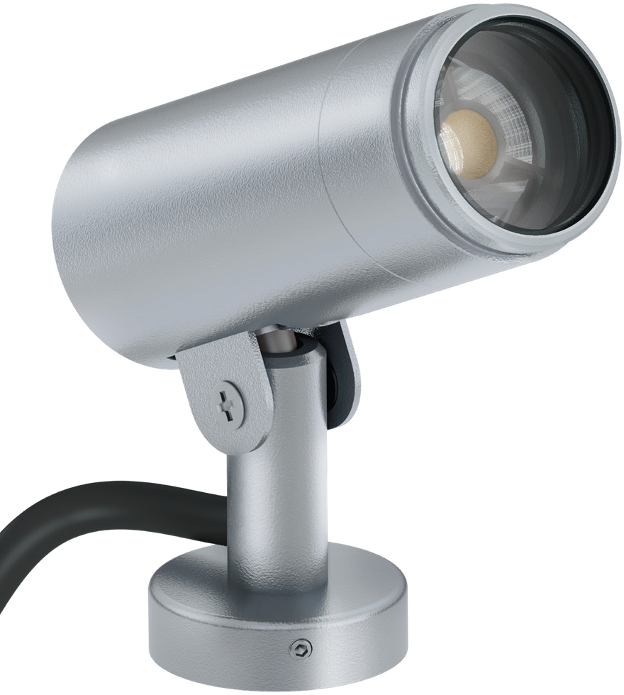 | nos | OLD QTY 6 | 7530 | 82830
 | Dimension: ∅=35mm, Ht=63mm |  |  |  | OLD QTY 6 | 7530 | 82830
 | Lamp:3W LED,45º, 3000K CRI=80+ |  |  |  | OLD QTY 6 | 7530 | 82830
 | Lumen Output : 230lm |  |  |  | OLD QTY 6 | 7530 | 82830
 | Control Gear: Remote LED Driver. Non-Dimmable. |  |  |  | OLD QTY 6 | 7530 | 82830
 | Power Consumption: 10.1W |  |  |  | OLD QTY 6 | 7530 | 82830
 | IP65 |  |  |  | OLD QTY 6 | 7530 | 82830
22 | Underwater LED Up Lighter.
 | Housing: Stainless Steel | UWL3 |  |  | Regret
 | Dimension: TrimØ=81mm, Cut OutØ=79mm & Ht=100mm. |  |  |  | Regret
 | Lamp: 6W LED, 10°, 3000K, CRI=80+ |  |  |  | Regret
 | Lumen Output : 576lm |  |  |  | Regret
 | Control Gear: Remote LED Driver. Dali Dimmable. |  |  |  | Regret
 | Power Consumption: 6W |  |  |  | Regret
 | IP68 |  |  |  | Regret
23 | Wall Mounted LED Light. |  |  | 5.00 | OLD QTY 6 | 14811 | 74055
  EWLR2-300-1030-K
 | Housing: Die cast Aluminium | WML1 |  | Nos | OLD QTY 6 | 14811 | 74055
 | Dimension: ∅=300mm, Ht=57mm |  |  |  | OLD QTY 6 | 14811 | 74055
 | Lamp:9W LED,92°×75°, 3000K CRI=80+ | 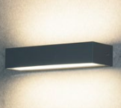 |  |  | OLD QTY 6 | 14811 | 74055
 | Lumen Output : 836lm |  |  |  | OLD QTY 6 | 14811 | 74055
 | Control Gear: Remote LED Driver. Non-Dimmable. |  |  |  | OLD QTY 6 | 14811 | 74055
 | Power Consumption: 9W |  |  |  | OLD QTY 6 | 14811 | 74055
 | IP65 |  |  |  | OLD QTY 6 | 14811 | 74055
24 | Wall Recessed LED Light. |  |  |  | OLD QTY 10 | 7378 | 81158
 | Housing: Die cast Aluminium | WRL1 | ELFR5-255-0630-K | 11.00 | OLD QTY 10 | 7378 | 81158
 | Dimension: ∅=255mm, Ht=67mm |  |  | Nos | OLD QTY 10 | 7378 | 81158
  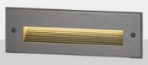
 | Lamp: 5.7W LED, 3000K CRI=80+ |  |  |  | OLD QTY 10 | 7378 | 81158
 | Lumen Output : CW=113 WW=104 |  |  |  | OLD QTY 10 | 7378 | 81158
 | Control Gear: Remote LED Driver. Non-Dimmable. |  |  |  | OLD QTY 10 | 7378 | 81158
 | Power Consumption: 5.7W |  |  |  | OLD QTY 10 | 7378 | 81158
 | IP65 |  |  |  | OLD QTY 10 | 7378 | 81158
25 | Wall Recessed LED FootLight | WRL2 | ELFR2-72-0330-K | 21.00 |  | 5590 | 117390
 | Housing: Die cast Aluminium |  |  | Nos |  | 5590 | 117390
 | Dimension: ∅=72mm, Ht=75mm |  | 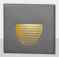 |  |  | 5590 | 117390
 | Lamp: 3.1W LED, 3000K CRI=80+ |  |  |  |  | 5590 | 117390
 | Lumen Output : CW=25 WW=22 |  |  |  |  | 5590 | 117390
 | Control Gear: Remote LED Driver. Non-Dimmable. |  |  |  |  | 5590 | 117390
 | Power Consumption: 3.1W |  |  |  |  | 5590 | 117390
 | IP65 |  |  |  |  | 5590 | 117390
26 | Wall Recessed LED Light. | WRL3 | ELFR5-255-0630-K | 6.00 | NEW ITEM | 7378 | 44268
 | Housing: Die cast Aluminium |  |  | Nos | NEW ITEM | 7378 | 44268
 | Dimension: ∅=255mm, Ht=67mm |  |  |  | NEW ITEM | 7378 | 44268
  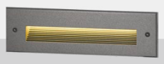
 | Lamp: 5.7W LED, 3000K CRI=80+ |  |  |  | NEW ITEM | 7378 | 44268
 | Lumen Output : CW=113 WW=104 |  |  |  | NEW ITEM | 7378 | 44268
 | Control Gear: Remote LED Driver. Non-Dimmable. |  |  |  | NEW ITEM | 7378 | 44268
 | Power Consumption: 5.7W |  |  |  | NEW ITEM | 7378 | 44268
 | IP65 |  |  |  | NEW ITEM | 7378 | 44268
 |  |  |  |  |  | Total | 4,000,000
 |  |  |  |  |  | GST 18% | 720,000
 |  |  |  |  |  | Grand Total | 4,720,000

Payment Terms
100% Advance
As discussed, 50% on PI and balance 50% before delivery dispatch

Company’s Bank Details
Bank Name: Central Bank of India
Account Number: 3167002097
Branch & IFS Code: Panaji & CBIN0280713

Terms & conditions apply.
Supply item only
Item once supplied cannot be returned.
Any physical damage to be informed at the time of delivery its self
If payment not received on time interest @ 15% will be levied per annum.
Any extra item if required to be charged as actual.
Warranty as per manufacturer not valid in case of surges, fluctuation, lightening etc.to be claimed directly with the
manufacturer without involving JP TECHATRONICS.
Supply done as per recommendation and request by client hence, JP TECHATRONICS or its employees should not be held responsible for any kind of malfunctioning of the system for any reasons.
Standard Terms and Conditions of JP Techatronics applied.
Logistics, inspection and Courier charges extra during warranty period in client scope.
Additional Services/ Service calls/ visits to be charged as actuals.

